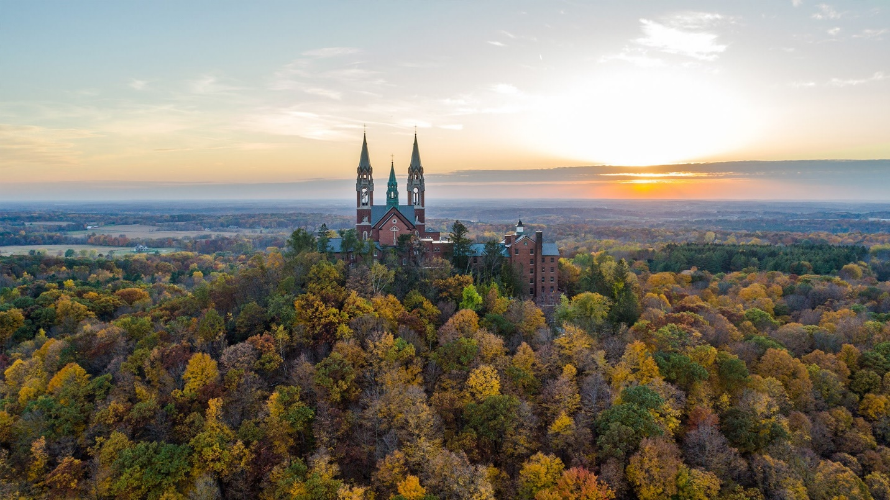

Holy Hill Pilgrimage

ITENERARY

Thursday, August 25 - about 12.5 miles

We will start at Sunset Park on the Glacial Drumlin Trail at 10:00 AM heading west and stop for lunch in the town of Wales. We then take the Ice Age Trail heading north through the Lapham Peak unit of the Kettle Moraine State Forest. From there, we will enter the town of Delafield and take the Lake Country Recreation Trail to Naga – Waukee Park. This is where we will camp for the night.

**Addresses:**

**Start:** Sunset Park, S30W28452 Sunset Dr, Waukesha, WI 53188

**Lunch:** Wales Park, 319 James St, Wales, WI 53183

**End:** Naga-Waukee Park, 651 Wisconsin 83, Hartland, WI 53029

**Timeline:**

6:30 AM:             Mass at St. Therese Chapel.

9:00 AM - 9:30 AM:       Arrive at Sunset Park.

9:30 AM:             Special Pilgrimage Blessing.

10:00 AM:                            Pilgrimage begins.

12:00 PM:            Arrive at lunch site in Wales.

1:00 PM:                             Leave lunch site.

3 - 3:30 PM:      Arrive at Lapham Peak Tower.

4:00 PM:          Leave and head to campground.

5:30 PM:             Arrive at Naga-Waukee Park.

**Setup Camp**

Friday, August 26 - about 11.5 miles

We will walk from Naga – Waukee Park, leaving at 9:30 AM, following the Ice Age Trail and some streets north into the town of Hartland and stopping for lunch at Nixon Park. We will then continue north on both the Ice Age Trail and several roads. We will end the day at Pollworth Park (White Tail Run, Hartland, WI 53029) near the town of Merton.

**Addresses:**

**Start:** Naga-Waukee Park, 651 Wisconsin 83, Hartland, WI 53029

**Lunch:** Nixon Park, 339 Maple Ave, Hartland, WI 53029

**End:** Pollworth Park (White Tail Run, Hartland, WI 53029) near the town of Merton.

**Timeline:**

7:30 AM:                               Mass at campsite.

8:30 - 9:00 AM:           Drivers shuttle vehicles.

9:30 AM:                                  Leave campsite.

12:15 - 12:30 PM: Arrive at Nixon Park/Lunch.

1:00 PM:                               Leave Nixon Park.

4:00 - 4:30 PM:  Arrive at Pollworth Park

**Head back to Naga-Waukee Park for overnight camping**

Saturday, August 27 - about 10 miles

We will begin at 9 AM, at the Milwaukee Polo Club (N75 W30343 County Road Vv, Hartland, WI 53029) driveway by Hwy Vv and walk the Ice Age Trail north through the woods to the village of Monches. Here we will have lunch on the grounds of the local Catholic Church, St. Theresa of Calcutta Parish (W314 N7462, State Rd 83, Hartland, WI 53029 -- in Monches not North Lake). From there, we will take the trail and certain roads north to finish at Holy Hill.

**Addresses:**

**Start:** Driveway of Milwaukee Polo Club, N75 W30343 County Road Vv, Hartland, WI 53029

**Lunch:**  St. Theresa of Calcutta Church, W302 N9583, O Neil Rd, Hartland, WI 53029

**End:** Holy Hill Basilica, 1525 Carmel Rd, Hubertus, WI 53033

**Timeline:**

6:45 AM:         Get up, breakfast, and pack up camp.

8:00 AM:                           Leave campground.

8:30 AM:           Drivers drop off people at the Milwaukee Polo Club driveway.

9:00 AM:             Begin walking at driveway of Milwaukee Polo Grounds

11:00 - 11:30 AM:        Arrive at St. Theresa of Calcutta Church/Lunch

11:45 AM - 12:15 PM:          Leave Lunch stop.

3:30 - 3:45 PM:                     Arrive at Holy Hill.

​